Model 1 Robust test 1

Residual Standard Error: 1.3303573442351524

Predicted R2 : 0.3335809510365161

Model 1 Robust test 2

Residual Standard Error: 0.120790620208312

Predicted R2 : 0.21834153949662705

Model 2 Robust test 1

Residual Standard Error: 1.2999851842415353

Predicted R2 : 0.3485599688377843

Model 2 Robust test 2

Residual Standard Error: 0.11907457135144316

Predicted R2 : 0.22923910128665392

Model 3 Robust test 1

Residual Standard Error: 1.299554592397469

Predicted R2 : 0.34865803861216615

Model 3 Robust test 2

Residual Standard Error: 0.11865015234352982

Predicted R2 : 0.23189945016980107

The result is a little bit different from the Version 6 jun.docx because of the changing to log(x+1)

1) distinct donors

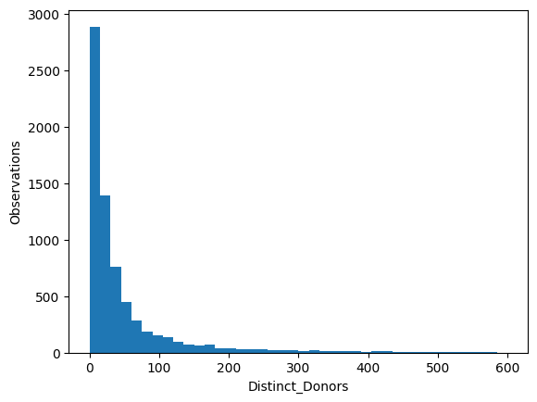

2) log distinct donors

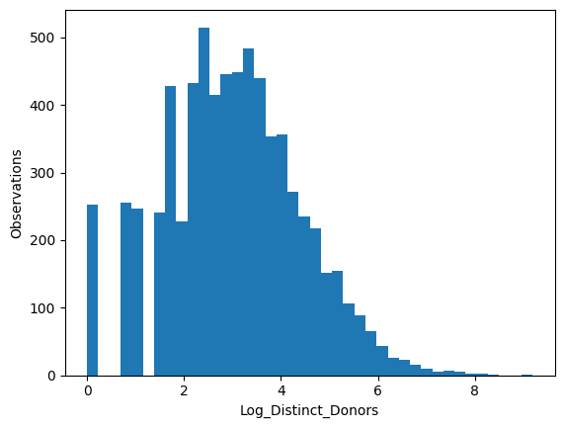

3) Campaign success

